SHORT-TERM RENTAL
FIRE SAFETY PLAN

(Name of Property Owner)

(Address)

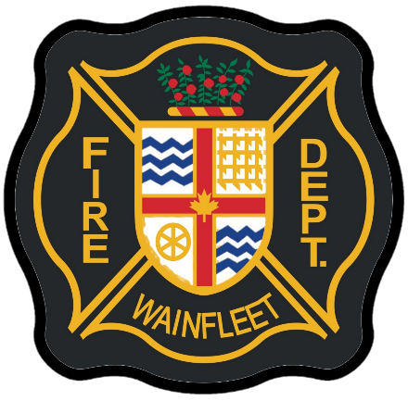

TABLE OF CONTENTS

- Overview Page 2
- Fire Protection & Life Safety Equipment Page 3
- Confining, Controlling and Extinguishing a Fire Page 4
- Fire Hazards and Precautions Page 7
- Responsibilities of the Owner Page 8
- Alternative Measures Page 9
- Training Page 10
- Building Schematics Page 12
- Sample Fire Escape Plan Page 13

1. OVERVIEW
1.1 OWNER & BUILDING INFORMATION
ADDRESS
Street Number
Street Name
Municipality
Province
Postal Code

OWNER INFORMATION
Name
Home Phone
Mobile Phone
Email

ALTERNATE EMERGENCY CONTACT
Name
Home Phone
Mobile Phone
Email

BUILDING INFORMATION
Building Area (square metres)
Occupant Load
To determine the occupant load use the following:
- Each bedroom is considered to accommodate two people
- A single sized bed is equal to one person and any larger sized beds equal 2 persons

In the event of a fire or emergency the owner,
or renter, if no owner on site, should:
- Alert the occupants of the fire – Yell “FIRE”
- Direct all occupants to exit the building
- Call 911 and notify the fire department of the emergency
- Ensure the safety of the occupants

1.2 FIRE DEPARTMENT TELEPHONE #’S
Emergency: 911
Wainfleet Fire & Emergency Services: 905-899-3463 ext 279

2. FIRE PROTECTION & LIFE SAFETY EQUIPMENT
2.1 FIRE EXTINGUISHERS – REFER TO SCHEMATIC DRAWINGS
Portable fire extinguishers, minimum sized 2A10BC, shall be installed on each level of the home, mounted in an accessible location on the wall and not in cupboards, cabinets or closets.

See drawing for exact location of extinguishers.

Service Company:
Note: Fire extinguishers must be maintained once every 12 months by a certified person or company.

2.2 SERVICE EQUIPMENT
Indicate the locations of the service equipment including the hot water tank, furnace, and electrical panel.
Locations:

2.3 EXIT LOCATIONS – REFER TO SCHEMATIC DRAWINGS
Exit Located:
Exit Located:

2.4 SHUT OFFS (GAS, WATER AND ELECTRICAL) – REFER TO SCHEMATIC DRAWINGS

Gas:
Water:
Electrical:

3. CONFINING, CONTROLLING AND EXTINGUISHING A FIRE

3.1 CONFINING, CONTROLLING & EXTINGUISHING
Confining a fire in an enclosed space will keep the fire, smoke and fumes from entering into a means of exit. In many cases this can be accomplished if one remembers to close the door when leaving the fire area.
Controlling a fire or preventing its spread, by closing the door in fire separated areas, will permit a reasonable period of time necessary for escape from the building.
In the event of a fire, judgement may be necessary in deciding which action is appropriate in a given situation.
In case of a pan fire:
Turn off the stove. If possible, smother flames with a pot lid or larger pan. Protect your hand with an oven mitt or wrapped dishtowel.
If the fire is not brought under control immediately follow emergency procedures. Never throw water or use flour on a grease fire.
In case of an oven fire:
Close the oven door and turn off the oven.
Never touch or attempt to carry a flaming pot. The contents may spill, spread or burn you. If the fire is not brought under control immediately follow emergency procedures.
What if I accidentally contact an open flame or hot substance?
If your clothing catches fire: stop where you are, drop to the ground, and roll back and forth to put the fire out.
Immediately cool a burn with cool running water under a tap for five to ten minutes and then seek medical attention.
NOTE
The production of noxious fumes in modern buildings makes any attempt at firefighting extremely dangerous to untrained personnel, particularly if a large amount of smoke is being generated. Fire extinguishment, control and confinement is primarily the responsibility of the fire department.

Your primary responsibility when you detect smoke or fire is to leave the fire area, taking other occupants with you, close doors behind you, and Dial 9ll and notify the fire department of the fire emergency.

DO NOT fight fire unless you are trained, properly equipped and confident of your ability to do so - life safety is priority. Make sure you have an escape route at all times and a backup person to assist you.
3.2 CLASSIFICATION OF FIRES
Learn how to operate the extinguishers in the building. Learn the classifications of fires.
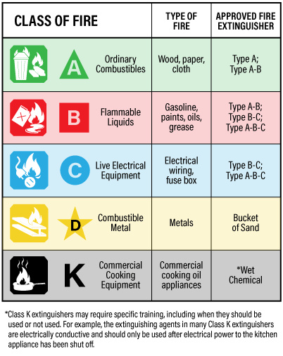

K = WET CHEMICAL FOR SUPPLEMENTATION OF KITCHEN EXTINGUISHING SYSTEM.
ONLY USE IF NECESSARY AFTER EXTINGUISHING SYSTEM HAS BEEN ACTIVATED.

Note:
Never use water on Class B, C or K class fires

Note:
Never use water on Class B, C or K class fires
3.3 FIRE EXTINGUISHER PROCEDURES
3.3.1.1 Before Extinguishing a Fire:
- Yell “FIRE” to notify the occupants
- Call 911 immediately
- Preferably, work with a partner
- Always have a safe exit route
- Never let fire come between you and your exit

3.3.1.2 To Extinguish a Fire:
- Choose an extinguisher with the correct classification
- Pull pin
- Aim at the base of the fire
- Squeeze handles on the fire extinguisher
- If here is any physical danger, leave the area and close the door

4. FIRE HAZARDS AND PRECAUTIONS

- A high standard of housekeeping and building maintenance is probably the most important single factor in the prevention of fire.
- Building must be kept clean and free of rubbish and other debris in all areas
- Combustible waste material must not be stored in any other area than designated areas.
- Store extra supplies in storage rooms.
- Do not block exits or routes to exits.
- Do not use combustible materials to absorb flammable or combustible liquid spills within the building.
- DO NOT use unsafe electrical equipment, frayed extension cords, over-loaded outlets.
- Combustible materials must not be stored with ashes in the same container.
- Flammable liquids must not be used for cleaning purposes.
- Use extreme caution when using items with open flames. Do not use flammable decorating materials.
- Turn off office equipment, etc. when not in use.
- Unplug coffeepots, toasters and other small appliances when not in use.
- Keep all cooking and exhaust equipment free of grease.
- Check pilots in stove to ensure they are lit.

5. RESPONSIBILITIES OF THE OWNER

- Fulfill duties during alarm and fire and ensure the safety of the occupants. In the event of fire, judgment may be necessary in deciding which action is appropriate in a given situation. It is your responsibility to make the selection that achieves the greatest protection for the occupants.
- Know emergency procedures.
- Ensure continued fire safety awareness within the building.
- Maintain the fire protection equipment in good operating condition at all times.
- Ensure regular scheduled maintenance checks, inspections and tests as per the Ontario Fire Code are completed on schedule.
- In the event of any shutdown of fire protection equipment, follow the alternative measures as outlined in the Fire Safety Plan.
- Know the location and function of all fire protection and life safety equipment in the building.
- Control fire hazards in the building.
- Notify the WAINFLEET FIRE & EMERGENCY SERVICES of any changes that will affect the Plan.
- Complete an annual review of the fire safety plan.

6. ALTERNATIVE MEASURES
Alternative Measures for the Portable Fire Extinguishers

Note: All equipment should be in correct operational condition at all times

The established procedure when a portable fire extinguisher is either used or not operational due to damage or lack of charge is as follows:

- Notify occupants by posting notices at the portable fire extinguisher location directing to the nearest portable fire extinguisher.

- Either replace the portable fire extinguisher with a new one of the same sizes and class, or call for immediate service by a fire protection company.
When the defective equipment has been repaired or replaced and is operational:
1. Remove the posted occupant notices.

7. TRAINING
The owner must be made familiar with emergency procedures as detailed in the fire safety plan. The development and implementation of the fire safety plan is the responsibility of the building Owner.

Emergency procedures must form a part of the training. It is presumed that such training will include certain basic items such as:

- Importance of prompt reporting of fire immediately to fire department.
- Importance of limiting and controlling fire and smoke spread.
- Importance of remaining calm.
- Importance of evacuating all persons from building calmly and quickly.

It is important that all of the staff survey the building to determine the number and locations of exits. They must be informed of fire hazards. They must know occupant emergency procedures as well as their own specific duties and responsibilities.

Designated staff must be trained to maintain fire protection and life safety equipment as laid out in “Maintenance Procedures for Fire Protection” section.

Regular maintenance must be performed on the fire and life safety equipment in the building in accordance with the Ontario Fire Code.

A written record shall be kept for all tests, corrective measures performed by Contractors. All records must be kept for a period of two years after they are made, and the records shall be made available upon request to the Chief Fire Official.

Fire Prevention Officers may check to ensure that the necessary checks, inspections and/or tests are being done, during the course of a fire inspection.

Included is a list of maintenance requirements that apply to your building.

Routine in-house maintenance can be completed by the Owner. The person/s performing maintenance must be properly trained to complete the work.

Most annual maintenance is technical and must be completed by competent contractor/s.
DEFINITIONS FOR KEY WORDS ARE AS FOLLOWS:
CHECK Means visual observation, to ensure the device or system is in place and is not obviously damaged or obstructed.

INSPECT Means physical examination, to determine that the device or system will apparently perform in accordance with its intended function.

TEST Means operation of the device or system to ensure that it will perform in accordance with its intended operation or function.

7.1 AFTER EVERY TENANCY – TO BE COMPLETED BY OWNER

Test all smoke alarms and carbon monoxide alarms by pushing the TEST button.

7.2 MONTHLY – TO BE COMPLETED BY OWNER

Check fire extinguishers and ensure the pressure gauge reading is in the operable range. Also check nozzle for obstruction and ensure seal or tamper indicators are in place. Ensure extinguishers have not been tampered with and are undamaged.

7.3 ANNUALLY – TO BE COMPLETED BY CONTRACTOR

Portable fire extinguishers are to be inspected for maintenance requirements and the necessary maintenance performed.

SPECIAL NOTE: SMOKE ALARMS AND CARBON MONOXIDE ALARMS

All smoke alarms need to be replaced every ten years, or before the indicated “replace by” date. If there are no dates indicated on the smoke alarm, it must be replaced. This includes hardwired alarms and battery-operated alarms.

All carbon monoxide alarms need to be replaced as per the manufacturer’s guidelines. The life of the carbon monoxide alarm varies for different makes and models. This includes hardwired alarms and batter-operated alarms.

SPECIAL NOTE: FIRE EXTINGUISHER INSPECTION AND/OR MAINTENANCE

Portable fire extinguishers are to be inspected for maintenance requirements and the necessary maintenance performed.

- Every six years from date of manufacture we and dry chemical extinguishers must have maintenance performed.

- Every twelve years from date of manufacture we and dry chemical extinguishers must have a hydrostatic test and a recharge.

Note: The manufacture date is found on the label or on the bottom of the extinguisher.

BUILDING SCHEMATICS

LEGEND FOR BUILDING/UNIT FIRE EMERGENCY SYSTEM

Description | Symbol
Entrance/Exit
Valves (General)
Identify the type of valve (e.g. shut off for natural gas, sprinklers, etc.)
Smoke Alarm
Carbon Monoxide Alarm
Combination (Smoke & CO) Alarm
Portable Fire Extinguisher – Class A | 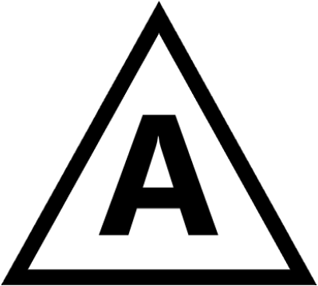
Portable Fire Extinguisher – Class B
Portable Fire Extinguisher – Class C
Portable Fire Extinguisher – Class D
Portable Fire Extinguisher – Class K | K
Portable Fire Extinguisher – Class ABC

The following shall also be indicated on the drawing:

- The direction north
- The street side of the building
- Rooms labelled by function (e.g. bedroom, kitchen, bathroom, etc.)

The evacuation route drawings shall be posted in all bedrooms on the back of the door.

If you require information on where smoke alarms and carbon monoxide alarms are required in your home, please contact Wainfleet Fire & Emergency Services at 905-899-3463 ext. 279.

7. FIRE ESCAPE PLAN

- Draw the layout of your home and include:
- Doorways
- Windows (if they can be used as exits)
- Fire Escapes (if in an apartment)
- Draw 2 floor plans if your house is two stories
- Label each room
- Draw a circle where there are smoke alarms
- Draw two ways out of each room
- Write “Exit” on each way out of the home
- Draw an “X” for a safe meeting place outside

